**Problem Statement:**

Creating an interactive chatbot for voice and text based interactions in a virtual environment by using AWS Services and giving the user an engaging experience.

**Objective:**

The ultimate goal is to prepare a **Virtual Exhibition.** The virtual exhibitions, also known as online exhibitions, are the complimentary counterparts to the physical exhibitions. They are used for putting digitized material into interpretive contexts. Such online exhibitions are available to any person with an active Internet connection. These exhibitions are available 24 X 7 without any restrictions whatsoever.

We proceed by creating virtual scenes consisting of different entities and objects organized in a virtual environment. These scenes can then be organized into projects. Projects can then be integrated to form an exhibition as a whole.

**Services Used:**

1. AWS Sumerian
2. AWS Lex
3. AWS Lambda
4. AWS CloudFormation
5. AWS IAM
6. AWS CloudFront

**Introduction:**

A chatbot is a conversational AI which interacts with the user via written or spoken language. Our chatbot is integrated within a 3D virtual environment which also consists of a wall television that is used for playing videos and adds to the aesthetics of the virtual environment. The user can interact with the bot using utterances and the prompts that we have preconfigured. With Amazon Sumerian, we can build an immersive and highly engaging virtual trainer experience without the need of any additional device or complex virtual reality platform management.

**Architecture Diagram:**

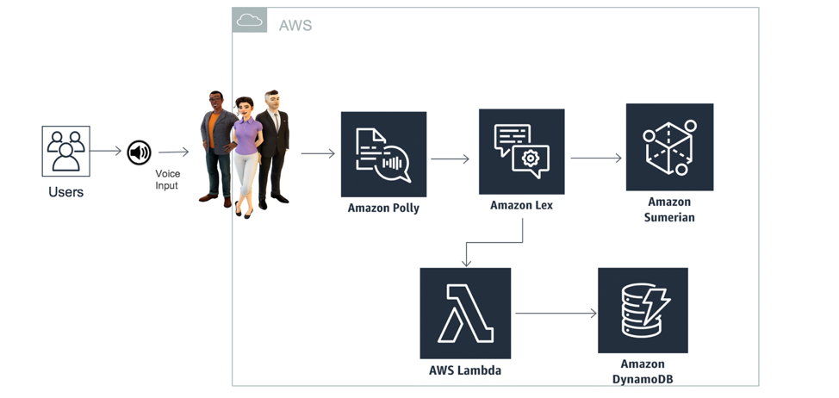

The above architecture makes use of Amazon Sumerian together with Amazon Lex and Amazon Polly with an out-of-box integration which is provided by an Amazon Sumerian host. Amazon Polly renders text to speech capability and Amazon Lex is utilized for the questions and answers bot. These questions and answers can be stored in Amazon DynamoDB and Amazon Lex is used to pull those questions and answers, using Amazon Lambda. The Lambda function (written in python) is used to update the configurations by adding it as a code hook. The scene, after completion, can be published directly to Amazon CloudFront as a website.

**Technology Stack:**

1. Python
2. Javascript
3. HTML
4. CSS

**Implementation:**

Sumerian is a service provided by AWS, using which we have created a virtual 3D environment (called as a scene). The objects that make up the scene are known as entities. For example, a television is an entity within the scene. A host within this Sumerian scene interacts with the user and provides live – timeresponses.

The host of this scene is in sync with Amazon Lex, which is used for creating chatbots using dialoguecomponents and state machine. The bot that we have created books a car for the user after asking his/her preferences (in the form of questions with the user). For example, the user can specify what type of car he/she wants.

The information required for such a conversation is written in the Lambda function, which initializes and validates the input provided by the user. This function, written in python, is then used to update the configurations by adding it as a code hook. All in all, lambda is the back end of the whole work.

This interaction with the bot can be done via text and voice. The responses of the bot can be heard. The bot responses can be also seen in the form of captions in the scene. All this happens in real – time and without any delays or wait.

**Challenges:**

1. Assets size :

We were required to import the client’s assets into the scene, the size of which exceeded 50MB. However, for importing assets the maximum size is 50MB. As a remedial measure, we used the build – in assets.

1. Accent issue :

Lex only supports US English Language, so it can only comprehend in that language. The input textbox feature that we have given counters this limitation up to some extent.

1. Superimposition of entities :

We needed to superimpose the entities – the TV and the video component. However, such a superimposition leads to an empty white screen around the TV – making the scene awkward. As a solution, we applied rigorous transformation to the entities of the scene to make things appear normal – maintaining the aesthetics of the virtual environment.

1. Using AWS Connect :

We were suggested to use the AWS Connect service for voice and chat experiences for enhancing the user experience. However, Connect, as a service is dedicated for contact center setup. Such a setup adds cost and hence is not an optimized way. To counter this, we added captioning of the bot responses. Moreover, the bot responses also appear in tandem, giving the user a seamless experience.

**Final Outcome:**

• Seamless experience with live time responses.

• Conversational AI which interacts via written or spoken language.

• Using various assets to maintain the aesthetics of the simulated environment.

**Future Prospects:**

• We can add animations to an entity in a virtual scene.

• We can use multiple tools like 3D modeling, lighting effects, audio editing, etc.

• Virtual exhibition in a COVID-19 like scenario.

• Gaming scenes.

• Virtual classes given by a host.

**Output:**

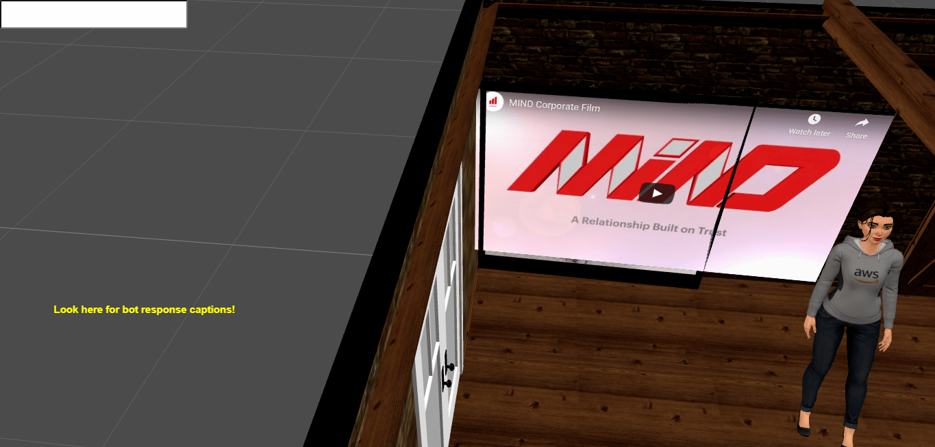

This is the how the virtual scene looks like. The following entities / objects / features can be observed:

1. The chatbot
2. A text box to enter the responses of the user
3. Captioning of the bot responses
4. A virtual room consisting of a wall TV which plays videos.

**Bibliography:**

<https://docs.aws.amazon.com/sumerian/latest/userguide/amazon-sumerian.html>

**---------Prachi, Piyush have worked on this.**